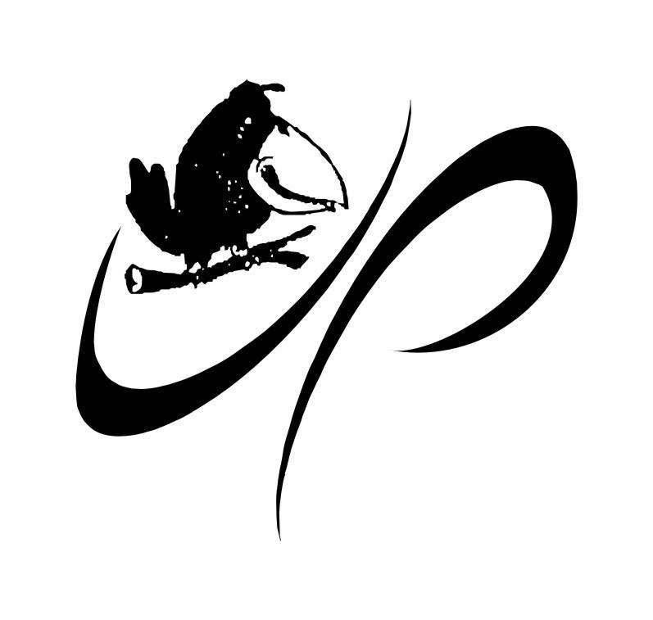
Underwood Park Netball Association Incorporated
Board Nomination Form
Note: Board nomination forms must be completed and returned to underwoodparknetball@gmail.com by no later than Friday 14th November 2023. Details of all nominations will be made available to members at least seven days prior to the AGM.

Nomination for the position of Board Member

Note: Two (2) Board member positions will be elected at the Annual General Meeting. Once board members are elected, they will elect the named positions from among themselves. These newly elected positions are two year positions in accordance with rule 5.1 of the association rules.
Name of candidate for position:

CANDIDATE’S DECLARATION:
- As a candidate for the position selected above, I do hereby solemnly declare that I am not ineligible to be elected as a member of the board under section 61A of the Associations Incorporation Act 1981 (the Act) (see below);
- I declare that I am eligible to remain a member of the board in accordance with section 64(2) of the Act (see below);
- I declare that I will promptly inform the association should I become ineligible to be a member of the board at any time during my term in office;
- I declare that I have no conflicts of interest or that I have declared all of my conflicts of interest arising as a result of my membership of the board (see below) and that I will promptly inform the association should any new conflict of interest arise;
- I understand my responsibilities and obligations as a member of the board, and will use my best endeavours to fulfil those responsibilities and obligations at all times;
- I understand that I may include a statement of up to 150 words relating to my experience and qualifications to be a member of the board of Underwood Park Netball Association and that the absence of a statement from me will not affect the publication of acceptable statements from other candidates;
- I declare that I will abide by the association’s rules, bylaws and codes of conduct at all times.
Signature of candidate:
Date:

DETAILS OF MEMBERS MAKING AND SECONDING THE NOMINATION:
Name of person making nomination (nominator):
Signature of nominator:
Date:
Club: |  | Club Position:
Name of person seconding the nomination (seconder):
Signature of seconder:
Date:
Club: |  | Club Position:

CANDIDATE’S STATEMENT OF EXPERIENCE AND QUALIFICATIONS:
The candidate may include a statement of up to an absolute maximum of 150 words relating to his or her experience and qualifications to be a member of the board of Underwood Park Netball Association. Any words over the 150-word limit will not be published.

If the statement is in a form acceptable to the Returning Officer, and is received no later than Friday 14th November 2023, it will be made available to members at least seven days prior to the AGM.

A candidate is not obliged to provide a statement, but the absence of a statement from one candidate will not affect the publication of acceptable statements from other candidates.
Maximum 150 words:

DECLARATION OF INTERESTS:
I declare the following interests:

APPENDIX A: BOARD SKILL MIX EVALUATION

To assist Underwood Park Netball Association in maintaining a balanced and skilled Board to represent its members and their interests, please indicate your experience for each of the following statements utilise the following scale:
- No experience;
- Limited experience (Awareness of the skill area);
- Adequate experience (Basic understanding of key concepts; i.e. completed some study in the area);
- Advanced experience (Professional experience in skill area; i.e. previous occupation or high level exposure);
- Specialist (Current profession with relevant qualification)
The matrix will be made available to members in addition to any supporting statement supplied by the candidate at time of nomination.
SKILL SET | EXPERIENCE
I have: | 0 | 1 | 2 | 3 | 4
- Experience and knowledge in Marketing and Branding.
- Experience and knowledge in Accounting and Finance.
- High performance experience in our Sport.
- A background and experience in Community sport and participation
- Experience and knowledge in Governance.
- Experience and knowledge in Legal.
- Experience and knowledge in Communications and Information Technology.
- Experience and knowledge in Government and Public Sector.
- Experience and knowledge in Corporate and Private Sector.
- Experience and knowledge in Research Techniques and Consumer Insights.
- Experience and knowledge in Commercialisation of Assets and Business Development.
- Experience and knowledge in Human Resources Management.

SKILL SET | EXPERIENCE
- Other skills and knowledge relevant to my role that have not been included: (List below)
I have: | 0 | 1 | 2 | 3 | 4
- WHS
- Experience in a non-government organisation/charity
- Info management
- Planning & organisation
- Change management
- Policy development
- Stakeholder engagement

Associations Incorporation Act 1981 EXTRACTS

Section 61A Eligibility for election to a management committee
- A person is not eligible to be elected as a member of an incorporated association’s management committee if—
- the person has been convicted—
- on indictment; or
- summarily and sentenced to imprisonment, other than in default of payment of a fine; and
- the rehabilitation period in relation to the conviction has not expired.
(1A) Also, a person is not eligible to be elected as a member of an incorporated association’s management committee if—
- under the Bankruptcy Act 1966 (Cwlth) or the law of an external territory or another country, the person is an undischarged bankrupt; or
- the person has executed a deed of arrangement under the Bankruptcy Act 1966 (Cwlth), part X or a corresponding law of an external territory or another country and the terms of the deed have not been fully complied with; or
- the person’s creditors have accepted a composition under the Bankruptcy Act 1966 (Cwlth), part X or a corresponding law of an external territory or another country and a final payment has not been made under the composition.
- In this section—
rehabilitation period has the meaning given in the Criminal Law (Rehabilitation of Offenders) Act 1986.

Section 64 Tenure of members of management committee
- The members of the management committee shall hold office and retire and may be removed from office as prescribed by the rules.
- The office of a member of the management committee shall be vacated in such circumstances (if any) as may be prescribed by the rules of the incorporated association or if the person holding that office—
- dies; or
- becomes bankrupt or compounds with creditors or otherwise takes advantage of the laws in force for the time being relating to bankruptcy; or
- is—
- convicted of an offence under this Act; or
- convicted of an indictable offence or an offence punishable on summary conviction for which the person is sentenced to imprisonment, other than in default of payment of a fine; or
- has been convicted on indictment or summarily and sentenced to imprisonment, other than in default of payment of a fine, and the rehabilitation period in relation to the conviction has not expired.
- In this section—
rehabilitation period has the meaning given in the Criminal Law (Rehabilitation of Offenders) Act 1986.

